REF - RAFMC/HB/2COMMUNICATION
ISSUE 1 - 2016

CLUB
COMMUNICATION

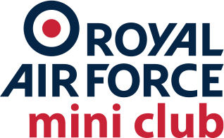

Contents

- Club Logo
- Digital Communication
- Social Media
- Templates

Annex A - Club Logo
Annex B - Club Laurel
Annex C - Login Information - Limited Access

Club Logo

Using the main logo

The Royal Air Force logo has been designed specifically so

that it can always be recognised clearly. Always use the logo when communicating on behalf of the Royal Air Force Mini Club.

The Royal Air Force Mini Club logo consists of the roundel and the words ‘Royal Air Force Mini Club'. These must always be used together. You must never alter the colours or shape of the logo, other than in the ways shown in these rules.

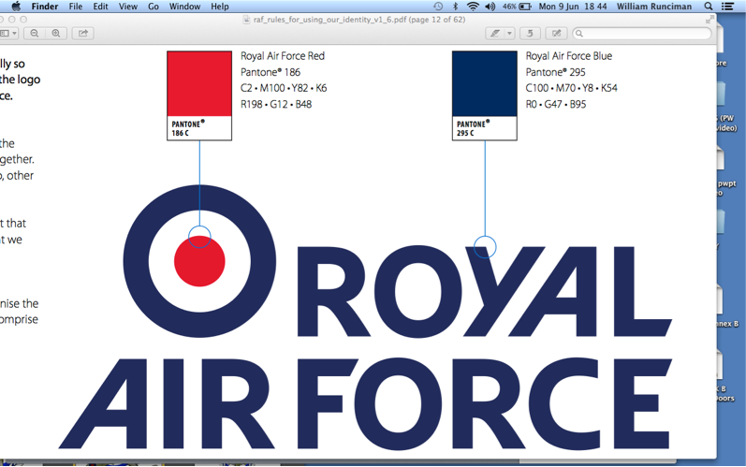
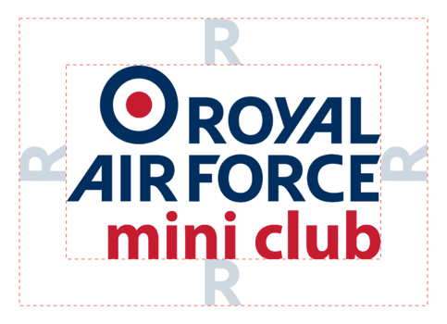
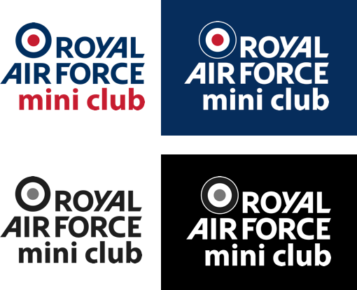
This is the preferred version of our logo. It's important that you use this version whenever possible to ensure that we use our colours consistently.

Logo exclusion zone

You must always keep a clear space - called the ‘exclusion zone' - around the Royal Air Force Mini Club logo to make sure that it stands out.

The clear space should be the height of the letter ‘R' in ‘Royal', on each side of the logo, as shown here.

Logo colour formats and treatments

The Royal Air Force Mini Club logo must always stand out clearly on communications.

Alternative versions of our logo have been created which work more effectively on specific backgrounds - for example, against dark colours.

Using the Laurel

The laurel provides a discrete alternative to the RAFMC logo.
The Royal Air Force Mini Club laurel consists of the roundel and Eagle of the RAF surrounded by a laurel famously adopted by the Mini brand. These must always be used together. You must never alter the colours or shape of the logo. This is the preferred version of our laurel. It's important that you use this version whenever possible to ensure that we use our colours consistently.

The RAFMC laurel should not be used on official RAF communications or media. The laurel is not authorised by the Air Command Centre and is not recognised by the RAF.

Digital Communication

Website www.rafmc.co.uk

Email contact@rafmc.co.uk

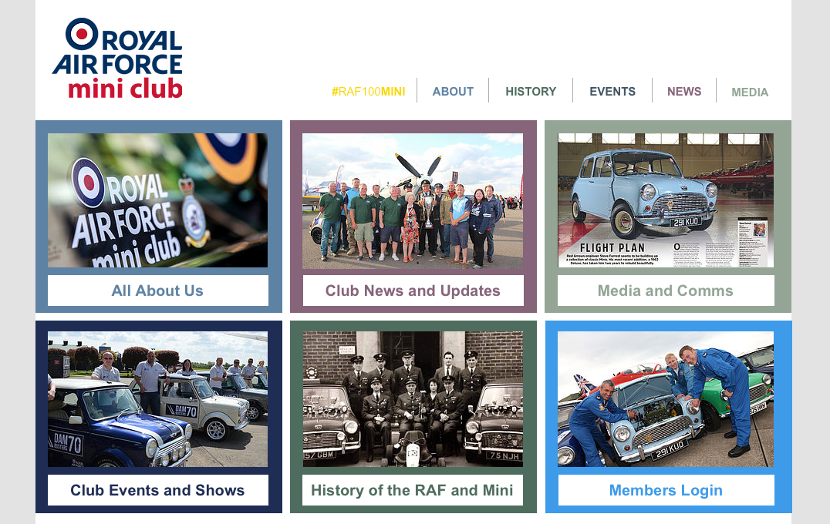

Social Media

- Facebook
- Twitter
- Instagram

Facebook

www.facebook.com/RoyalAirForceMiniClub

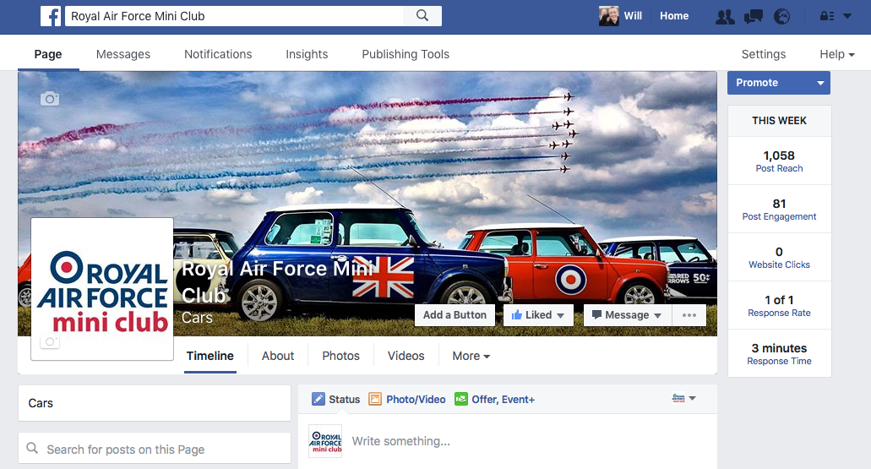
www.facebook.com//groups/rafmcforum/

Twitter

www.twitter.com/RAFMiniClub

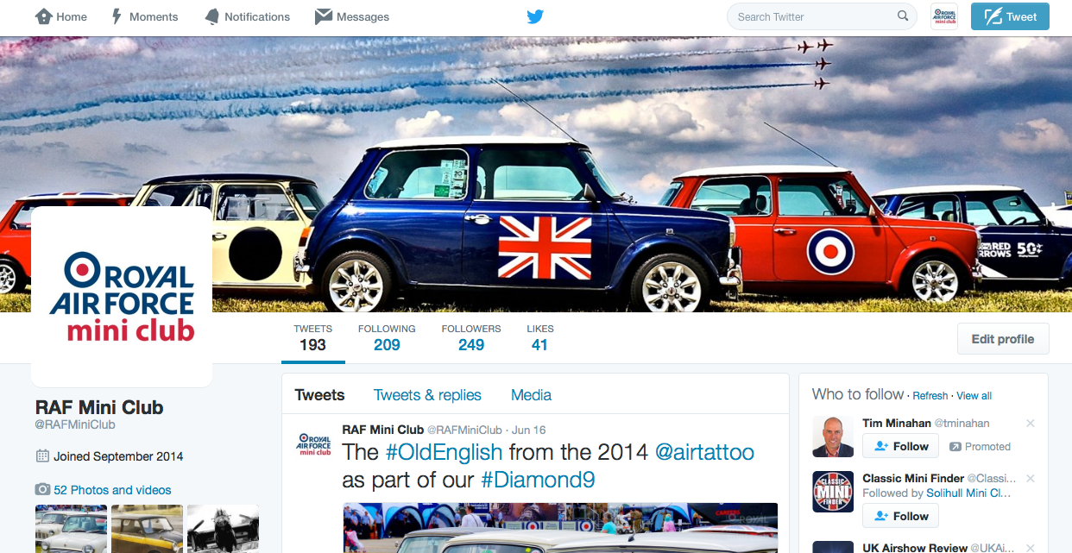

Instagram

https://www.instagram.com/rafminiclub/

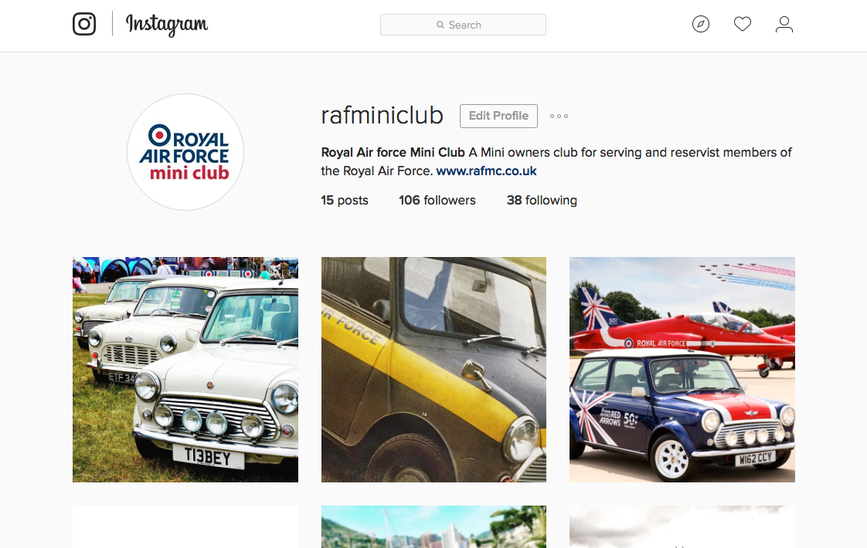

Contact Card
www.RAFMC.co.uk

contact@RAFMC.co.uk

@RAFMiniClub

www.facebook.com/RoyalAirForceMiniClub

